Metro Jets
Umpire Handbook
2019

Umpires are an integral part of the game of netball
“If there are no umpires, there is no game!”
Contents
WELCOME TO THE METRO JETS …………………………………………………………………………………………3
Mission
Vision
Our commitments
METRO JETS OFFICE BEARERS 2019…………………………………………………………………………………….4
CLUB CONTACT DETAILS……………………………………………………………………………………………………..5
Coaches and Umpires Association
UMPIRING AT THE METRO JETS NETBALL CLUB………………………………………………………………….6
2019 Umpires
Metro Jets umpiring coordinator
Umpiring payments and requirements
COMENCING UMPIRING……………………………………………………………………………………………………….8
Why umpire?
Process
UMPIRE PATHWAYS……………………………………………………………………………………………………………9
UMPIRING IN SOUTH AUSTRALIA……………………………………………………………………………………...10
Coloured Shirt Program
Updating umpire level
Umpiring code of behaviour
METRO JETS EXPECTATIONS……………………………………………………………………………………………..12
Expectations of players towards umpires
MATCHES AND TRAINING INFORMATION………………………………………………………………………….13
MATCH DAY ROLES…………………………………………………………………………………………………………...14
INTERNATIONAL NETBALL FEDERATION – OFFICIAL RULE UPDATE………………………………...16
2017 official rule change summary
2018 official rule amendment summary
2019 official rule amendment summary
2019 Net Set Go – Set rules
NATIONAL UMPIRE DEVELOPMENT FRAMEWORK…………………………………………………………..17

Welcome to the Metro Jets

The Metro Jets Netball Club, formerly Western Jets Netball Club, was founded in 1995, participates in South Australia’s elite netball competitions: the State Premier League Netball Competition (Nine News Netball Cup); the Adelaide Metropolitan Netball Division and the City Night Division, all of which are hosted at Priceline Stadium, home of the Adelaide Thunderbirds.
Despite still being relatively new, Metro Jets continues to grow and experience success across their grades. In 2014, Metro Jets were endorsed as one of eight Premier League Clubs to compete at the highest level in South Australia, becoming a true ‘Pathway Club’ to the Adelaide Thunderbirds.
Metro Jets are extremely proud of the growth and development achieved in their short history. The Club has developed a strong, supportive and professional environment of exceptional standards that aims to inspire and promote players, coaches and umpires to reach their full potential.
Today, the Metro Jets proudly field over 25 teams in Netball SA’s elite competitions, making us a ‘Club of Choice’ in South Australia.
Go Jets!

Mission
We strive to develop, promote and encourage our players, coaches, umpires and officials to reach their full potential.
Vision
To be a successful high-performance pathway club in South Australia.
Our commitments
Our commitments that underpin our Vision and Mission are to:
- Promote and actively encourage fair play from all involved with the club
- Build the best possible environment for our players, members, and the wider community
- Always act with integrity and transparency and provide best business practices for all our stakeholders.

METRO jets Office Bearers 2019

Executive Committee
Meetings held on a monthly basis with all expected to attend
President  Rachael McLeod | Vice President  Tracy Brokate | Secretary  Katrina Wood | Public Officer  Judith Dingwall | Treasurer  Brenda Dombi

Club Officers
Club Officers will be engaged by the Committee on issues impacting their Specific Area. All officers are expected to maintain records to meet the KPI requirements of NSA.
Premier League Coordinator  Jill White | Sponsorship Coordinator  Andrew Jeynes | Coaching Coordinator  Tracy Brokate | Records Officer  Shirley Mencel | Communications Officer  Linda Jarmer | Volunteer Coordinator  Katrina Wood | Game Day Coordinator  Judith Dingwall

Merchandise Officer | Equipment Officer
Candece Nicholls | Brayden Lyle
Sub-Committee Members
Laura Gilbert | Cathy O’Dea | Christine Dunbar

Trials & Development
The following Officers will work closely with their designated Club Officer
Trial Coordinator  Tracy Brokate | Court Coordinator  Candece Nicholls | Umpire Coordinator  Caitlin North | Coaching Development  Andrew Plenty | TID/Regional Coordinator  Andrew Plenty

METRO JETS NETBALL CLUB ADDRESS PO Box 367
Woodville SA 5022

EMAIL secretarymetrojets@gmail.com

WEBSITE www.metrojets.com

BANK DETAILS Metro Jets Netball Club
BSB: 105-018
Acct #: 080 324 740

FACEBOOK Metro Jets Facebook
INSTAGRAM Metro Jets Netball Club
TWITTER Metro Jets Netball Club

UMPIRE COORDINATOR CAITLIN NORTH 0415 756 606
TREASURER BRENDA DOMBI 0412 824 828
SECRETARY KATRINA WOOD 0418 472 536

Coaches and Umpires Association
All Metro Jets umpires are required to be members of the Netball SA Coaches and Umpires Association. Membership runs annually from 1 April to 31 March the following year. As a member, you will receive up to date information on all activities involving both umpiring and coaching such as, umpiring & coaching courses and workshops, exam information and development opportunities.

Umpiring at Metro Jets Netball Club

2019 Umpires
The Metro Jets Netball Club would like to thank their club umpires for their ongoing dedication, professionalism and commitment. The umpires for the 2019 season are as listed:

2019 Metro Jets Umpires
Adrian Marshall | Isabelle Grinham
Alexia Desyllas | Jada Vella
Alicia Bais | Kaylinn Rootman
Annalese Dunbar | Kinsey Todd
Ava Roles | Laura Duncan
Caitlin Eichner | Lisa Cawdron-White
Caitlin North | Madison Knighton
Ekaterina Angelou | Montana Dunbar
Emalie Checuti | Q’Hara Rootman
Emily Marshall | Sarah Browning
Emily Sowsberry | Tahlia North
Imogen Graham | Teagan Dunbar
 | Zoe Desyllas

Roles of the umpiring coordinator
The umpire coordinator must:
- Actively seek, support and develop Club umpires
- Arrange appropriate umpires for: Match Day; Trials/Training Sessions; and Practice Matches
- Provide umpiring experience and mentoring in club
- Organise training & development of umpires and arrange Club support when needed
- Record the number of games umpired by each umpire and liaise with Treasurer re: payment
Should any issues or queries arise during the season, please contact Metro Jets Umpire Coordinator, Caitlin North on 0415 756 606 or umpiringmetrojets@gmail.com

Umpiring payments and requirements
During the Winter season, Metro Jets umpires receive direct debit payments on a fortnightly basis. During the Summer season, all umpires are paid cash by the City Night office. Umpires will also receive a single-entry pass for the night they umpire. Payments are outlined below:

Accreditation | Payment per game
Unbadged | $25
C badged | $30
B badged | $35
A badged | $40

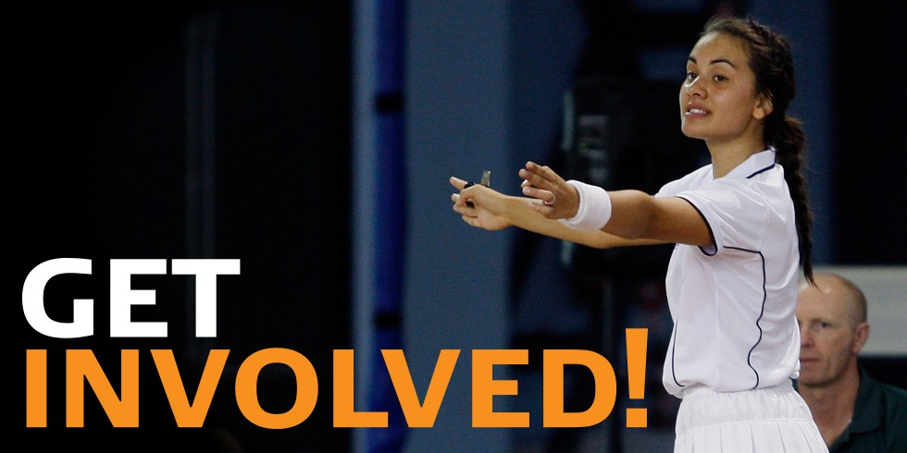

Commencing Umpiring at Metro Jets NC

Umpiring is an integral component of netball. Umpires apply the rules to the best of their ability, without fear or favour, making decisions in the best interests of the game. Skilled umpiring enhances the game by complementing and encouraging skilled play, for the enjoyment of all participants and spectators alike.

Why umpire?
Have you ever considered the benefits of becoming an umpire?
Umpiring provides you with so much more than just the ability to officiate the rules of the game. It can make you feel:
- Connected – Umpiring is a great way to make new friends and be part of the vibrant netball community.
- Respected – Umpires facilitate a safe, fair and enjoyable environment for netball players. Umpiring develops skills that can be used for life: communication, resilience and leadership.
- Energised – Umpiring lets you experience the thrill of the game, contributes towards maintaining a healthy lifestyle and offers a pathway to participate in sport at the highest level.

What’s the process?
- Express your interest in an email to umpiringmetrojets@gmail.com, or follow the enquiry section on the umpiring page and click submit.
- Purchase the latest version of the INF Rule Book, from the NSA online shop.
- Sit the Rules of Netball Theory Exam, online via NSA.
- Attend the “Learn How to Umpire Course”. Our umpiring coordinator will send out regular emails to new umpires.
- Complete the Foundation Umpire Education Course, online via NSA.
- Register with the Netball SA Coaches/Umpires Association.
- Purchase white attire so you can begin umpiring!

Umpire Pathways

There are many opportunities to become involved as an umpire in netball, with clear pathways and support structures available for those aspiring to officiate at the highest level.

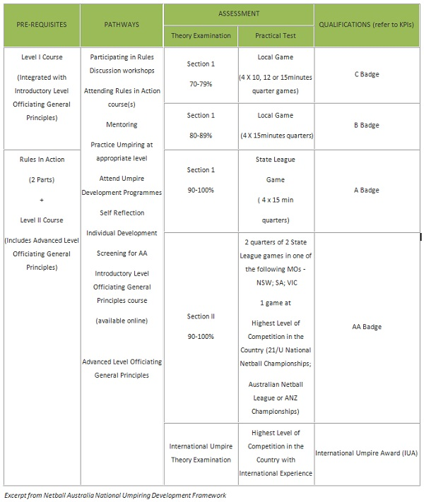
Umpiring in South Australia

Netball SA provides a range of development programs for umpires of all levels. Opportunities exist for umpires at association, regional, state and national levels.
The Netball Australia umpire accreditation system is a structured pathway based on umpiring courses, Rules in Action and practical umpiring instruction through an experience mentor system. The accreditation system leads to a practical assessment in a 4-tiered system of badges, namely C, B, A and the highest national award the AA.

Coloured Shirt Program
The Coloured Shirt Program is an initiative, developed by Netball SA and the Office of Recreation and Sport, where new or inexperienced officials where a coloured shirt that makes them easily recognisable. The primary objective is for people to identify these officials as “leaners” and understand that they may make mistakes and that harassment to these umpires will not be tolerated. The secondary objective of this initiative is to provide mentoring and support to the umpire.
There are several pre-requisites for umpire participants – have less than two years umpiring experience, be unbadged, be a current member of the Coaches/Umpires Association, and be willing to align their umpire development with the Netball Australia pathway by completing the relevant prerequisites.

Updating umpire level
To update an ‘on court’ umpire accreditation, an umpire must attain a higher badge level, or attend at leave one professional umpire education unit (theory examination, rules in action or umpire course) within six years of obtaining a badge.
An experienced umpire, regardless of badge level, who is returning to umpiring, may update as above. However, in accordance with normal practise, umpire allocation will be based on performance.

Umpiring Code of Behaviour
In addition to Netball Australia’s General Code of Behaviour, you must meet the following requirements regarding your conduct during any activity held by or under the auspices of Netball Australia, Member Organisation or Associates in your role as an umpire.
- Umpire in accordance with the Official Rules of the Game
- Treat all players, coaches, match officials and other umpires with respect
- Place the safety and welfare of the players above all else
- Ensure the court and its surrounds are complaint with the rules
- Take appropriate action to manage dangerous play
- Maintain a high standard of personal behaviour always
- Be a positive role model through behaviour and personal appearance projecting a favourable image of netball and umpiring always
- Be courteous, respectful and open to discussion and interaction
- Maintain or improve your current performance level and seek continual improvement

Metro Jets Expectations

The Metro Jets Netball Club has expectations for all players, coaches, umpires and spectators are as follows:
- Respect all opposition players, coaches, umpires and spectators
- Respect all Jets players, coaches, umpires, spectators and committee
- Remember that players participate for pleasure and winning is only part of the fun
- Operate within the rules and spirit of the sport
- Make the experience for all players, coaches, umpires and spectators a positive experience
- All players to have equal court time where possible during minor round matches
- Display control, respect and professionalism to all involved in the sport
- Any physical contact with a young player should be appropriate to the situation and necessary for the player’s skill development
- Respect the rights, dignity and worth of every person regardless of their gender, ability, cultural background or beliefs
- Show concern and caution towards sick and injured players, follow the advice of a physician when determining whether an injured player is ready to commence training or matches
- At all times, represent the Club with dignity and sportsmanlike behaviour
- Support the Club and its members at trainings, matches and Club functions.

Expectation of players towards umpires
The club would like players to be aware of several items regarding player/umpire relationships.
- It is essential that players learn to listen to the umpire for directions during the match, not the coach (or parents/spectators)
- All players benefit from learning the skill of adapting their game to the umpires they have. At times it seems bad calls are made by the umpires, but being a good sport means taking the bad decisions with the good
- Remember to use the correct protocol to address concerns about umpiring. During a break, the Captain (and ONLY the Captain) may approach the umpires to discuss concerns
- Our umpires are out there to help our teams play their best game. If we don’t have umpires, players can’t play the game. Please remember to be respectful to all umpires, perhaps even thank them after each game.

Matches and Training Information

All Metro Jets teams train and play at Priceline Stadium – 155 Railway Terrace, Mile End. The stadium caters for all levels of competition and is the home of the Adelaide Thunderbirds.

Age grade | Player age (as of December 31) | Winter games (Apr – Sept) | Summer games (Oct – Mar)
Net Set Go – Set | 9 & under | Saturday 9:00am | Friday 6:30pm
Primary | 11 & under | Saturday 9:00am | Friday 6:30pm
Sub-junior | 13 & under | Saturday 10:00am | Friday 7:30pm
Junior | 15 & under | Saturday 11:00am | Friday 8:30pm
Intermediate | 17 & under | Saturday 12:30pm | Tuesday 7:00pm or 8:30pm
Senior | 18 & over | Saturday 2:00pm or 3:30pm | Tuesday 7:00pm or 8:30pm
Premier League & Premier League Reserves | 18 & over | Thursday 7:00pm or 8:45pm | NA

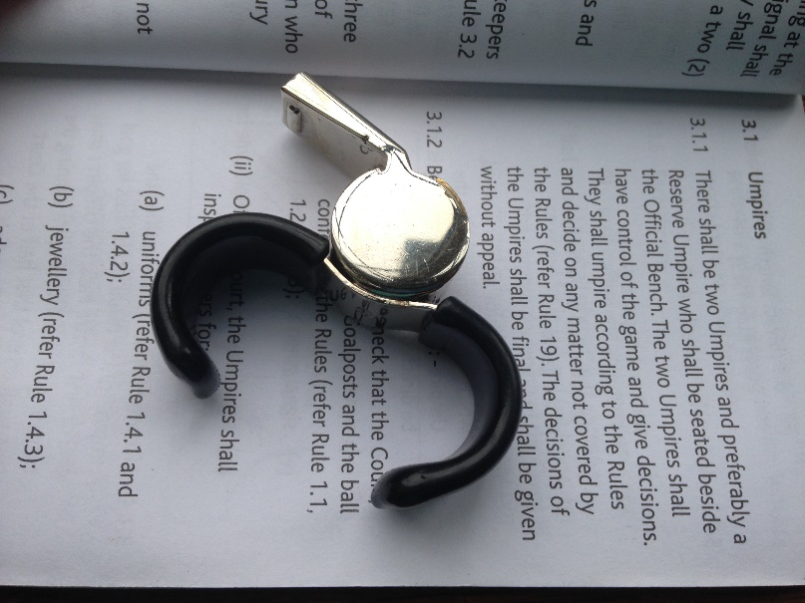

Match Day Roles

As an umpire, you will need to be aware of the roles that people play on match day. It takes many committed people to make it possible for our Metro Jets players to play a game of netball.
Primary carer
Each team must have a primary carer (preferably with some form of first aid training) to attend to injuries/illnesses. However, there is no mandatory requirement regarding the first aid training. The primary carer had the duty of care to respond appropriately in the case of injury/illness. The primary carer is the only person allowed on court during an injury timeout unless the injured player needs support to be moved from the court. Coaches and parents are not allowed on court in the process.
Scorer
All players will go on a roster to provide a scorer and timer throughout the season. The scorer for each team needs to:
- Be over 16 years of age
- Sit or stand with the opposition scorer
- Print the umpires name of the scorecard prior to the match
- Tick the box next to each player’s name as they take the court
- Record all centre passes and goals
- Goals must be scored each quarter numerically (ie 1, 2, 3)
- Total the number of goals each quarter
- Confirm scores throughout the match with the opposition
- Total the number of goals for the match
- Both captains are to sign the score card following the match
- Return scorecard to Duty Office following the match
Timing
The timer for each team needs to:
- Be over 16 years of age
- Sit or stand with the opposition time
- If timing quarters, follow the umpire at 10 seconds to go and call “time” when the timer beeps.
- If timing breaks, advise the umpire of 30 seconds, 10 seconds and time.
The home team is always in charge of timing quarters, and this varies depending on the age group. Sub junior, primary and Net Set Go grades have 4 x 10-minute quarters. All Junior, inter and senior grades have 4 x 15-minute quarters. The away team is always in charge of timing breaks and injury time. Breaks are 3, 5, 3 minutes (respectively). Injury time is up to 30 seconds, and must be timed.
International Netball Federation – Official Rule Update

2017 official rule changes
A summary of the rules changes (as of August 2017) include:
- Umpires no longer blow their whistle when goals are scored and if it is clear that the ball is out of court.
- The use of the word ‘Penalties’ has been changed to ‘Sanctions’. Sanctions will include Free Pass or Pass/Shot. Throw In and Toss Up are considered actions as opposed to Sanctions (or penalties under the current version).
- When taking a centre pass, the Centre is required to now only have one foot wholly within the centre circle.
- Once a player taking a penalty pass is in the correct position, the player may choose either to play the ball immediately or to wait for the infringer to stand out of play. However, it is important to note that the changes to the rule regarding the taking of the penalty pass do not remove the requirement for a player who is sanctioned for a major infringement to stand out of play.
- All injury/illness stoppages, which will include blood, will be 30 seconds, and the injured player must come off the court.
- Goal tending will no longer be allowed. Players will not be able to deflect a shot once the ball is on a downward flight towards the ring, including touching the ball up through the net.
Netball Australia has also updated the online Level 1 umpires course and Section 1 umpire theory exam with the new rule changes and these are both now available to complete via the MyNetball Learning Portal.

2018 Official Rules Amendments
The International Netball Federation (INF) has announced the latest update of its rules of the game. The changes will take effect for all matches played in Australia, and all international games, on January 1 2018. These updates reflect the amendments to the 2016 rules that were approved at INF Congress in July 2017, and are not new rules but small changes.
The amendments include:
- New definitions of breaking, pivot and set (for a free pass and penalty pass)
- The sanction if a free pass or penalty pass is taken in an incorrect position
- When a player who is in the correct position may take the penalty pass
- Umpires hold time to give a caution and new caution signal added
- Change of ‘official warning’ to ‘warning’ throughout rules book
- Suspension period is 2 minutes playing time
- State when a player may move into the court surround
- Minor tidy up to remove duplication and provide clarity
It is recommended that all umpires visit the Netball SA website to view the video series available that explains these amendments.
2019 Official Rule Changes
No changes as at date of writing

Net Set Go – Set Competition Rules
Match duration |  | 4 x 10 minute quarters (players should experience all positions over the course of the program/season)
Goal post |  | 2.4m (8 ft.) in height
Ball |  | Size 4
Held ball |  | A player must throw the ball within five (5) seconds
Centre pass |  | The coin toss at the start of the game will determine who takes the first centre pass. All other centre passes shall be taken by the team that did not score the last goal including the centre pass at the start of each quarter
Stepping |  | Shuffling on the spot to regain balance is allowed providing the player doesn’t move down the court
Defending |  | ‘One-on-one’ defence can occur throughout the match. Players may defend a shot at goal
Obstruction |  | A player may defend a player in possession of the ball, provided there is not less than 1.2m (4 ft.) from the landing position of the player with the ball
Substitutions |  | A team may make unlimited substitutions at intervals or at any time during play. The game time should be evenly distributed amongst all players
Procedure of substitutions during play |  | - Before entering the court, the substitute shall tag the player leaving the court  - Both the substitute and the player leaving the court shall not interfere with the play during the substitution process  - Both the substitute and the player leaving the court shall observe the Offside Rule when leaving or entering the court  - Players should be substituted into either only attack positions or only defence positions for the duration of the game

National Umpire Development Framework

